Using Velocity Engine To Process Template

Summary: This document will describe a way of how to use velocity as standard alone application to send email with the features of internalization. A simple example is given to send email in English and Chinese.

Key words: Velocity, Resource Bundle, format currency, format date, UTF-8, Apache email.

This example is about car reservation. The car rental company sent email to the customer after the customer made a reservation.

Reservation Data
Java bean data objects:
- Guest records customer’s first name, last name and email address
- Car presents type of car of rental, FORD, TOYOTA etc.
- Reservation encapsulates confirmation number, a guest, a car, charge, days of rental and start rental date.

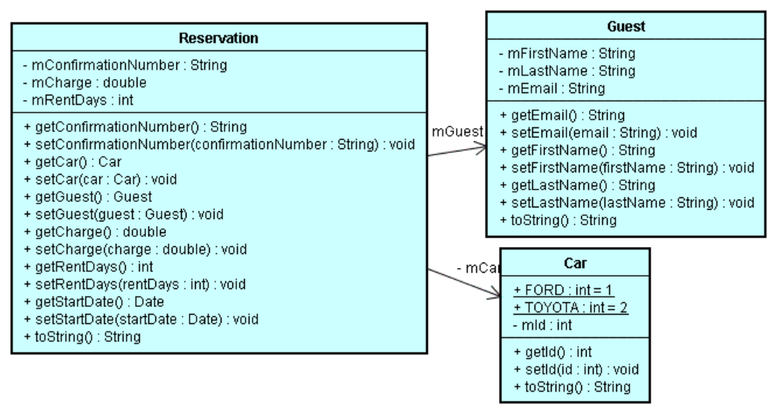

Test
TestVelocity is used to construct test data and call template process and then send email.
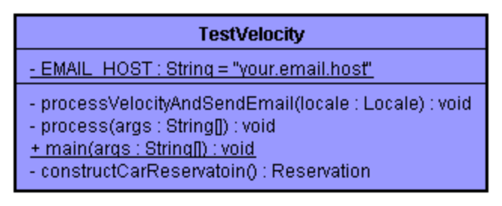
public class TestVelocity
{
private static Logger sLogger = Logger.getLogger( TestVelocity.class.getName() );

/**
* email host server
* You got to change it to your email host.
*/
private final static String EMAIL_HOST = "your.email.host";

/**
* Process Velocity template and send email
* @param locale
* @throws Throwable
*/
private void processVelocityAndSendEmail(Locale locale)
throws Throwable
{
sLogger.info( "processVelocityAndSendEmail" );

//prepare data for template
Reservation reservation = constructCarReservatoin();

if (sLogger.isDebugEnabled()) {
sLogger.debug("\n");
sLogger.debug( reservation.toString() );
}

//1. get email body
ReservationTemplateProcessor resTemplateProcessor = new ReservationTemplateProcessor();
String body = resTemplateProcessor.processReservationTemplate( reservation, locale );

//2. send email
String subject = "Welcome to rent Ford's car";
String fromAddress = "rent.car@ford.com";
String toAddress = reservation.getGuest().getEmail();

if (sLogger.isDebugEnabled()) {
sLogger.debug("\n");
sLogger.debug( "body=" + body );
}

EmailUtils emailUtils = new EmailUtils();
emailUtils.setHostName( EMAIL_HOST );
emailUtils.sendEmail( fromAddress, toAddress, subject, body );
}

/**
* process
* @param args
* @throws Throwable
*/
private void process(String[] args)
throws Throwable
{

String arg1="en";
if (args.length>0) {
arg1 = args[0];
}

Locale locale = null;
if ("zh".equalsIgnoreCase( arg1 )) {
locale = new Locale("zh", "CN");
}
else {
locale = new Locale("en", "US");
}

sLogger.info( "language="+arg1);

// 1. test velocity
processVelocityAndSendEmail(locale);
}

public static void main( String[] args )
{
try {
String log4j = System.getProperty( "log4j.configuration", "log4j.properties" );
sLogger.info( "log4j="+log4j);

PropertyConfigurator.configure(log4j);

sLogger.info("Entering application.");

new TestVelocity().process(args);

} catch( Throwable e ) {
e.printStackTrace();
}
}

/**
* Construct fake data for testing
* @return
*/
private Reservation constructCarReservatoin()
{
Reservation reservation = new Reservation();
reservation.setConfirmationNumber( "124457788" );

Guest guest = new Guest();
guest.setFirstName( "Bob" );
guest.setLastName( "Park" );
guest.setEmail( "michael.wang@ichotelsgroup.com" );

reservation.setGuest( guest );

Car car = new Car();
car.setId( Car.FORD );

reservation.setCar( car );

reservation.setCharge( 123.56 );
reservation.setRentDays( 2 );

Date today = new Date();
reservation.setStartDate( today );

return reservation;
}
}

TestVelocity initializes log4j, constructs data through constructCarReservatoin() method, takes language value from command argument and call constructCarReservatoin(Locale locale) to process template to get body of email and send email.

Note: private final static String EMAIL_HOST = "your.email.host";
The your.email.host needs to be your real email server in order to send email.

Reservation Process
ReservationTemplateProcessor is created to decouple velocity service from test client TestVelocity,java. It sets default resource bundle path and velocity template location.

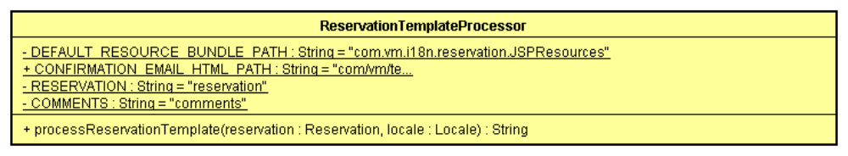
The method of processReservationTemplate does two things:
- takes reservation and locale objects to fill TemplateRequest with default resource bundle path, locale, template location, reservation and comments.
- call TemplateProcessorFactory to get VelocityTempateProcess instance and invoke velocity process by passing templateReuqest value.

Notes:
- So far, there is not velocity code involved.
- The default resource bundle path set here is for convenience, in template you can use different resource bundle.

Template Process
Template process relies on velocity template engine to process reservation template with reservation object.
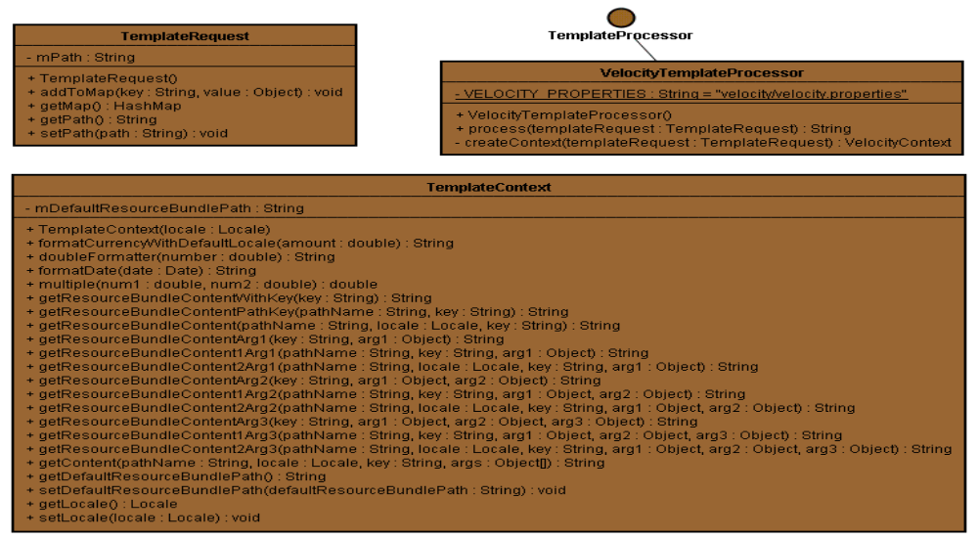
The constructor of VelocityTemplateProcessor loads velocity properties from classpath and initialized Velocity Engine.
public VelocityTemplateProcessor()
{
InputStream iStream = Thread.currentThread().getContextClassLoader().getResourceAsStream(VELOCITY_PROPERTIES );

Properties props = new Properties();
if ( iStream == null ) {
throw new TemplateProcessorException(
"Could not find velocity configuration file: velocity/velocity.properties in class path" );
}
try {
props.load( iStream );

mVelocityEngine = new VelocityEngine();
mVelocityEngine.init( props );

} catch( Throwable e ) {
throw new TemplateProcessorException( "could not initilize ", e );
}
}

The method of createContext method creates instance of TemplateContext and save local, default resource bundle path to it.
Additionally, it sets local, default resource bundle path and encoding type to VelocityContext.
The encoding type is defined in velocity properties file to VelocityContext.

Note:
- TemplateContext is created and saved to velocityContext. The purpose of doing this is for the call back from template to display resource bundle content, currency format, decimal format, date and time format etc.
- Velocity Macro is defined in velocity configuration file and is loaded to VelocityEngine also.

private VelocityContext createContext( TemplateRequest templateRequest )
throws TemplateProcessorException
{
try {
VelocityContext context = new VelocityContext();

/*---------------------------------------------------
* add common setting here ...
*---------------------------------------------------*/

Locale locale = (Locale)templateRequest.getMap().get(
TemplateConstant.TMPL_LOCALE );

TemplateContext templateContext = new TemplateContext(locale);

String defaultResourceBundlePath = (String)templateRequest.getMap().get(
TemplateConstant.TMPL_DEFAULT_RESOUCE_BUNDLE_PATH );
templateContext.setDefaultResourceBundlePath( defaultResourceBundlePath );

context.put( TemplateConstant.TMPL_CONTEXT_REFERENCE, templateContext );

context.put( TemplateConstant.TMPL_LOCALE, locale );
context.put(
TemplateConstant.TMPL_DEFAULT_RESOUCE_BUNDLE_PATH, defaultResourceBundlePath );

// adding output encoding type: TMPL_OUTPUT_ENCODING
context.put(
TemplateConstant.TMPL_OUTPUT_ENCODING,
mVelocityEngine.getProperty( "output.encoding" ) );

return context;

} catch( Throwable e ) {

throw new TemplateProcessorException( "Could not createContext "
+ templateRequest.toString(), e );
}
}

The method of process takes templateRequest object and create Template object.
The values of templateRequest are passed to VelocityContext.

Note: As configuration file defines input.encoding=UTF-8, so we do not need to do anything in this method for processing UTF-8.

public String process( TemplateRequest templateRequest )
throws TemplateProcessorException
{

sLogger.debug( "Start template processing" );

try {
Template template = mVelocityEngine.getTemplate( templateRequest.getPath() );

VelocityContext context = createContext( templateRequest );

// 1. assign client value to velocity context
Map vMap = templateRequest.getMap();
String key;
Object value;
if ( vMap != null ) {
Iterator it = vMap.entrySet().iterator();
while ( it.hasNext() ) {
Map.Entry entry = (Map.Entry)it.next();
key = (String)entry.getKey();
value = entry.getValue();
context.put( key, value );
}
}

// 2. bind with context and return String Writer
StringWriter writer = new StringWriter();
template.merge( context, writer );
writer.close();

return writer.getBuffer().toString();

} catch( Throwable e ) {
throw new TemplateProcessorException( "Could not process template "
+ " request is " + templateRequest.toString(), e );
}
}

Email Template
Velocity does not care the file extension, we use html so that we can view the layout easily.

vm_macro.html is macro file and load as velocity init. It defines many useful macros for formatting, retrieving resource bundle etc.
#*
* vm_macro.vm
* include all common macro for vm template.
*
*#

#*-- define macro to retrieve --*#

#*-----------------------------------------------------------------
* define resource content macro
* #vm_content("email_new_reservation_html.sectionheader.reservationresources" )
*
* #set( $resourceBundle = "com.ihg.dec.framework.uiServices.i18n.resources.jsp.common.reservation.JSPResources" )
* #vm_content1($resourceBundle "email_new_reservation_html.sectionheader.reservationresources" )
* #vm_content2($resourceBundle $locale "email_modified_reservation.resmail.sectionheader.yourresmod" )
*------------------------------------------------------------------*#
#macro(vm_content $key)${tmplContext.getResourceBundleContentWithKey( $key)}#end
#macro(vm_content1 $resourceBundle $key)${tmplContext.getResourceBundleContentPathKey( $resourceBundle, $key)}#end
#macro(vm_content2 $resourceBundle $locale $key)${tmplContext.getResourceBundleContent( $resourceBundle, $locale, $key)}#end

#*-----------------------------------------------------------------
* define resource content macro with one argument
* #vm_content_arg1("email_new_reservation_html.sectionheader.reservationresources", $arg1)
*------------------------------------------------------------------*#
#macro(vm_content_arg1 $key $arg1)${tmplContext.getResourceBundleContentArg1( $key, $arg1)}#end
#macro(vm_content1_arg1 $resourceBundle $key $arg1)${tmplContext.getResourceBundleContent1Arg1( $resourceBundle, $key, $arg1)}#end
#macro(vm_content2_arg1 $resourceBundle $locale $key $arg1)${tmplContext.getResourceBundleContent2Arg1( $resourceBundle, $locale, $key, $arg1)}#end

#*-----------------------------------------------------------------
* define resource content macro with two arguments
* #vm_content_arg2("email_new_reservation_html.sectionheader.reservationresources" $arg1 $arg2)
*------------------------------------------------------------------*#
#macro(vm_content_arg2 $key $arg1 $arg2)${tmplContext.getResourceBundleContentArg2( $key, $arg1, $arg2)}#end
#macro(vm_content1_arg2 $resourceBundle $key $arg1 $arg2)${tmplContext.getResourceBundleContent1Arg2( $resourceBundle, $key, $arg1, $arg2)}#end
#macro(vm_content2_arg2 $resourceBundle $locale $key $arg1 $arg2)${tmplContext.getResourceBundleContent2Arg2( $resourceBundle, $locale, $key, $arg1, $arg2)}#end

#*-----------------------------------------------------------------
* define resource content macro with three arguments
* #vm_content_arg3("email_new_reservation_html.sectionheader.reservationresources" $arg1 $arg2 $arg3)
*------------------------------------------------------------------*#
#macro(vm_content_arg3 $key $arg1 $arg2 $arg3)${tmplContext.getResourceBundleContentArg3( $key, $arg1, $arg2, $arg3)}#end
#macro(vm_content1_arg3 $resourceBundle $key $arg1 $arg2 $arg3)${tmplContext.getResourceBundleContent1Arg3( $resourceBundle, $key, $arg1, $arg2, $arg3)}#end
#macro(vm_content2_arg3 $resourceBundle $locale $key $arg1 $arg2 $arg3)${tmplContext.getResourceBundleContent2Arg3( $resourceBundle, $locale, $key, $arg1, $arg2, $arg3)}#end

#*-----------------------------------------------------------------
* define currency format
* #vm_currency($myres.floatAmount "USD")
*-----------------------------------------------------------------*#
#macro(vm_currency $amount)${tmplContext.formatCurrencyWithDefaultLocale($amount)}#end

#*-----------------------------------------------------------------
* define date format: long, short etc
* #vm_date(${myres.checkOutDate})
*-----------------------------------------------------------------*#
#macro(vm_date $date)${tmplContext.formatDate($date)}#end

#*-----------------------------------------------------------------
* define time format
*-----------------------------------------------------------------*#
#macro(vm_time $time)${tmplContext.formatTime($time)}#end

#*-----------------------------------------------------------------
* text line break
*----------------------------------------------------------------*#
#macro(vm_textLineBreak)

#end

reservation_html_confirmation.html is the template for email body:

<html dir="ltr">
<head>
<META http-equiv=Content-Type content="text/html; charset=${outputencoding}">
<title> #vm_content("car.rental") </title>
</head>

<body>
#set( $carResources = "com.vm.i18n.car.JSPResources" )
<table border="0" cellSpacing=2 cellPadding=0 width=650>
<tr>
<td colspan="2">
<b>#vm_content("welcome").
#vm_content_arg1("confnum " ${reservation.confirmationNumber})
</b>
</td>
</tr>

#set ( $guest = $reservation.guest)
<tr>
<td>#vm_content("firstname"): </td> <td> ${guest.firstName}</td>
</tr>

<tr>
<td> #vm_content("lastname") :</td> <td>${guest.lastName} </td>
</tr>

<tr>
<td> #vm_content("total.price") : </td> <td>#vm_currency(${reservation.charge}) </td>
</tr>

<tr>
<td> #vm_content("rental.day") :</td> <td> ${reservation.rentDays}</td>
</tr>

<tr>
<td> #vm_content1($carResources "car.brand") </td> <td> #vm_content1($carResources "car.brand.${reservation.car.id}") </td>
</tr>

<tr>
<td> #vm_content("start.date")</td> <td>#vm_date(${reservation.startDate}) </td>
</tr>
</table>

reservation_html_confirmation.html template utilizes VTL language and vm_macro.html marco.

#vm_content("firstname") calls
#macro(vm_content $key) ${tmplContext.getResourceBundleContentWithKey( $key)}#end in vm_macro.html
In turn, TemplateContext. getResourceBundleContentWithKey(String key) is getting called to retrieve content for the key with default resource bundle path.

#set( $carResources = "com.vm.i18n.car.JSPResources" ) defines alternative resource bundle.
#vm_content1($carResources "car.brand.${reservation.car.id}") is the usage of using it.

#vm_currency(${reservation.charge}) calls
#macro(vm_currency $amount)${tmplContext.formatCurrencyWithDefaultLocale($amount)}#end
In turn, TemplateContext. formatCurrencyWithDefaultLocale(double amount) is called and format currency with the locale we passed in through createContext we talked before.

Sending Email
EmailUtils
Once we got email body, next thing we need to do is to send email.
Apache email package is applied here.

public void sendEmail(String fromAddress,
String toAddress,
String subject,
String body) throws EmailException {
HtmlEmail email = new HtmlEmail();
//email.setHostName("mail.myserver.com");
email.setHostName(mHostName);
email.addTo(toAddress);
email.setFrom(fromAddress, "Ford Rent Company");
email.setSubject(subject);
email.setCharset( "UTF-8" );

//set the html message
email.setHtmlMsg(body);

//send the email
email.send();
}

By assigning UTF-8 to charset email.setCharset( "UTF-8" );
, the email will be delivered as UTF-8.

The End
This article and sample example were intentionally omit many details regarding Velocity, please refer Velocity document for detail syntax.

Java version: 1.5

Build/Execute
In velocity\script directory

1. clean
clean.bat

2. set email host
Replace EMAIL_HOST = "your.email.host" from TestVelocity.java with your email host

3. build
build.bat

4. run: default for en_US
run.bat [lang_Region]

for example
run.bat zh
run.bat en
run.bat

The Result

For English version: run.bat en
Welcome to use our car rental service. Your Confirmation Number: 124457788
First Name: | Bob
Last Name : | Park
Total Price : | $123.56
Rental Days : | 2
Brand | FORD
Start Date | September 21, 2006

For Chinese version: run.bat zh
欢迎使用我们的汽车租赁业物. 您的确认号码是: 124457788
名字: | Bob
姓名 : | Park
租赁费 : | ￥123.56
租赁天数 : | 2
车品牌 | 福特
开始日期 | 2006年9月21日

